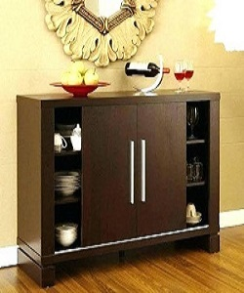

Modern and stylish Poliform showcase

$84.96

Availability: In stock

### Description

Hollow design makes better use of storage space, and have two extra drawers. The design of the table is very practical, you can use it as side table etc., providing more functions for any space, whether at home or in the office, easy to clean with a damp cloth. Upgrade your living room interior with this sleek showcase in gloss brown look and simple design.